 support@ipitomy.com | 941.306.2200
________________________________________________________________

Configuration of Valcom VIP-172L Door Phone

This document will inform the IPitomy Technician on the configuration and installation of the Valcom VIP-172L SIP based Door Phone.

The VIP – 172L IP Talkback Door phone/intercom that allows communication to Valcom FXS units and SIP based Telephone systems via a managed IP based LAN/WAN

The first step in setup is to create an Extension in the PBX for the VIP to use. Simply navigate to Destinations and then Extensions within the PBX and manually create one extension. Make note of both the Extension number and the Extension SIP password as this is required to be populated within the VIP for it to register. The device type for your Extension should be generic.

You must install the Valcom Configuration utility to configure the Valcom. This is provided on a CD that is included within the package for the VIP. Once installed the software will search your network for connected Valcom devices.

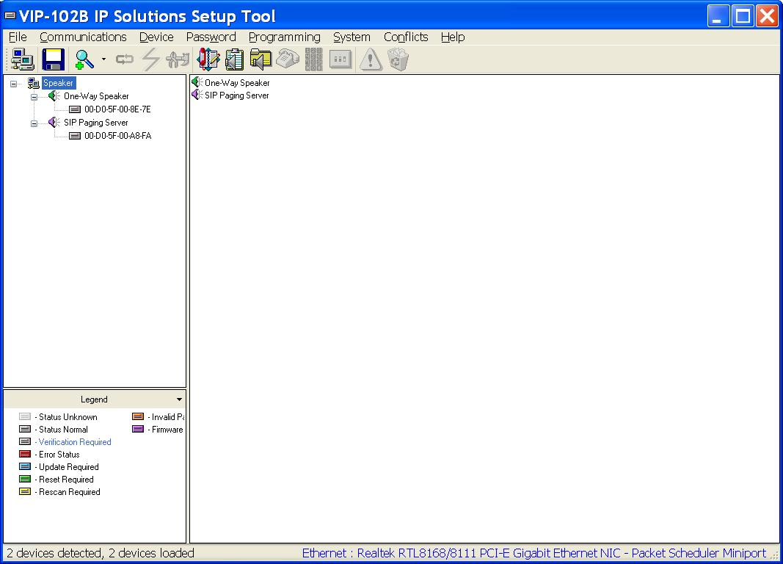

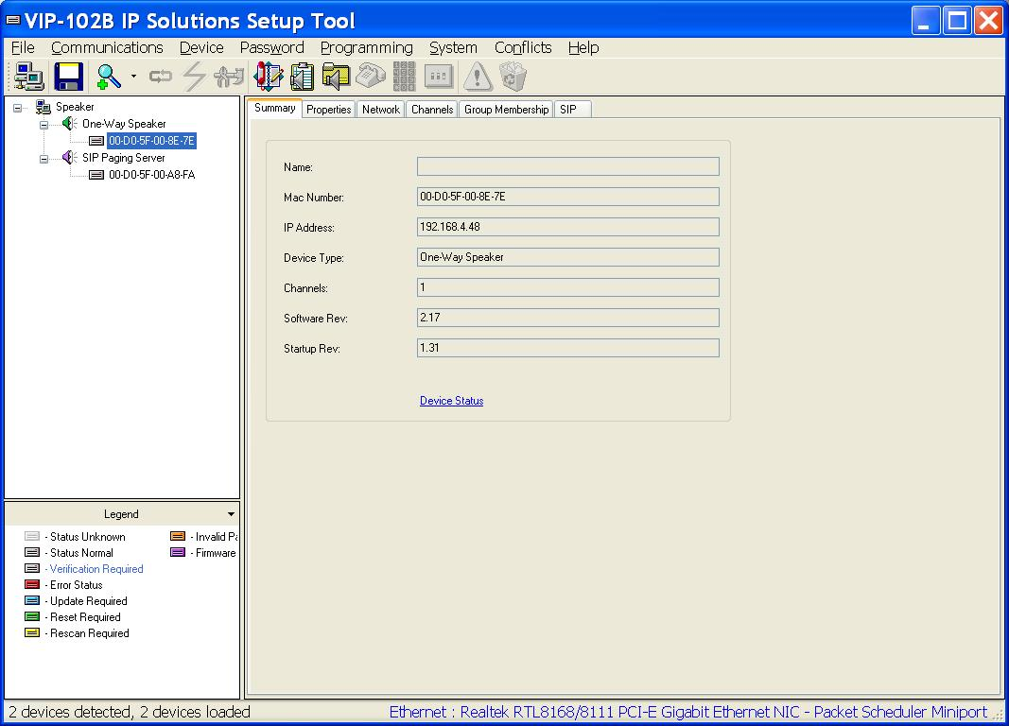

The software displays to you a list of the connected devices it finds. Select the VIP from the list and you can then configure it.
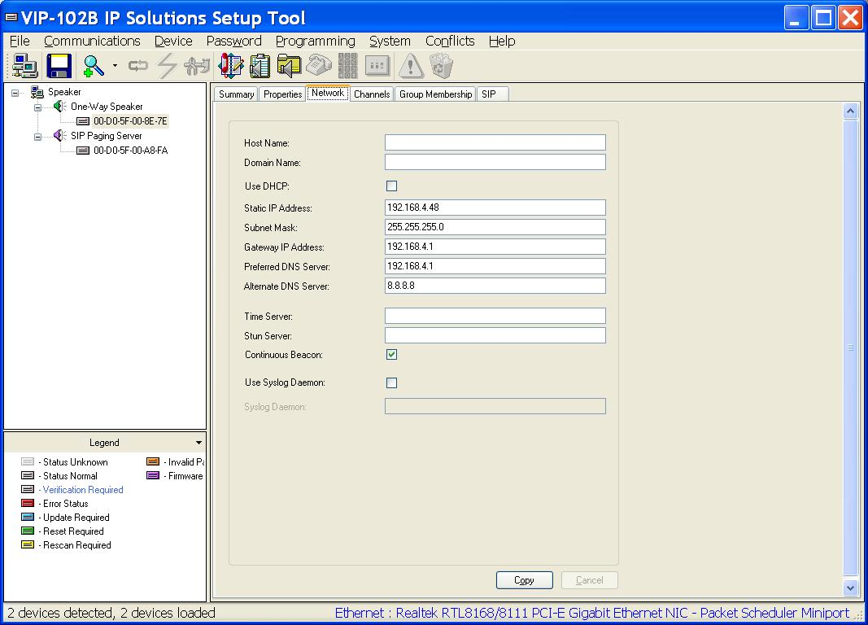

You will need to configure the Network settings first. You may use either a static assignment or dynamic. IPitomy generally recommends dynamic assignments be used.

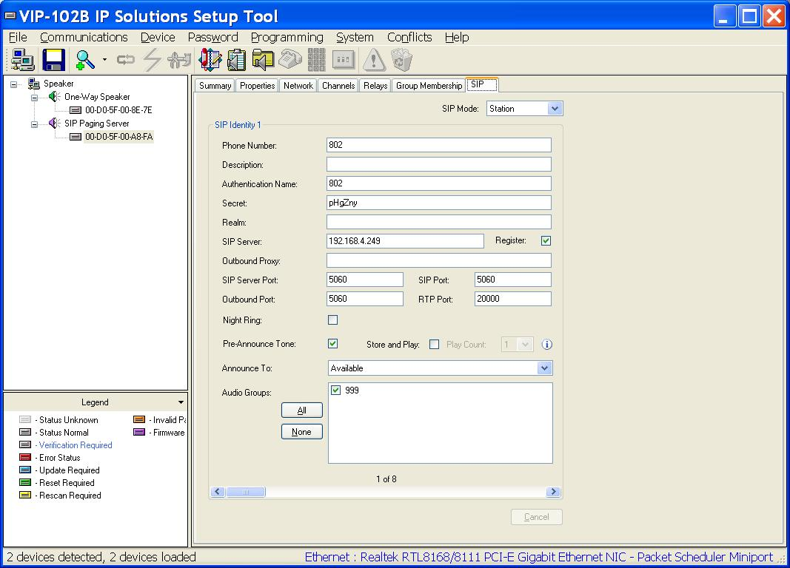

You should then configure the SIP settings. This will include the IP of the IPitomy PBX for the SIP server field and the Phone number and Authentication fields and the SIP password is used in the Secret field. The rest of the page may be left at its defaults.

